Лабораторная работ 12

Defining Advanced Attribute and Dimension Properties
The remaining lessons in this tutorial are based on an enhanced version of the Analysis Services Tutorial project that you completed in the first three lessons. Additional tables and named calculations have been added to the Adventure Works DW 2012 data source view, additional dimensions have been added to the project, and these new dimensions have been added to the Analysis Services Tutorial cube. In addition, a second measure group has been added, which contains measures from a second fact table. This enhanced project will enable you to continue learning how to add functionality to your business intelligence application without having to repeat the skills you have already learned.
Before you can continue with the tutorial, you must download, extract, load and process the enhanced version of the Analysis Services Tutorial project. Use the instructions in this lesson to ensure you have performed all the steps.

Downloading and Extracting the Project File
- Click here to go to the download page that provides the sample projects that go with this tutorial. The tutorial projects are included in the adventure-works-multidimensional-tutorial-projects.zip download.
- Click adventure-works-multidimensional-tutorial-projects.zip to download the package that contains the projects for this tutorial.
By default, a .zip file is saved to the Downloads folder. You must move the .zip file to a location that has a shorter path (for example, create a C:\Tutorials folder to store the files). You can then extract the files contained in the .zip file. If you attempt to unzip the files from the Downloads folder, which has a longer path, you will only get Lesson 1.
- Create a subfolder at or near the root drive, for example, C:\Tutorial.
- Move the adventure-works-multidimensional-tutorial-projects.zip file to the subfolder.
- Right-click the file and select Extract All.
- Browse to the Lesson 4 Start folder to find the Analysis Services Tutorial.sln file.

Loading and Processing the Enhanced Project
- In SQL Server Data Tools, on the File menu, click Close Solution to close files you won't be using.
- On the File menu, point to Open, and then click Project/Solution.
- Browse to the location where you extracted the tutorial project files.
Find the folder named Lesson 4 Start, and then double-click Analysis Services Tutorial.sln.
- Deploy the enhanced version of the Analysis Services Tutorial project to the local instance of Analysis Services, or to another instance, and verify that processing completes successfully.

Understanding the Enhancements to the Project
The enhanced version of the project is different from the version of the Analysis Services Tutorial project that you completed in the first three lessons. The differences are described in the following sections. Review this information before continuing with the remaining lessons in the tutorial.

Data Source View
The data source view in the enhanced project contains one additional fact table and four additional dimension tables from the AdventureWorksDW2012 database.
Notice that with ten tables in the data source view, the diagram is becoming crowded. This makes it difficult to easily understand the relationships between the tables and to locate specific tables. To solve this problem, the tables are organized into two logical diagrams, the Internet Sales diagram and the Reseller Sales diagram. These diagrams are each organized around a single fact table. Creating logical diagrams lets you view and work with a specific subset of the tables in a data source view instead of always viewing all the tables and their relationships in a single diagram.

Internet Sales Diagram
The Internet Sales diagram contains the tables that are related to the sale of Adventure Works products directly to customers through the Internet. The tables in the diagram are the four dimension tables and one fact table that you added to the Adventure Works DW 2012 data source view in Lesson 1. These tables are as follows:
- Geography
- Customer
- Date
- Product
- InternetSales

Reseller Sales Diagram
The Reseller Sales diagram contains the tables that are related to the sale of Adventure Works products by resellers. This diagram contains the following seven dimension tables and one fact table from the AdventureWorksDW2012 database:
- Reseller
- Promotion
- SalesTerritory
- Geography
- Date
- Product
- Employee
- ResellerSales
Notice that the DimGeography, DimDate, and DimProduct tables are used in both the Internet Sales diagram and the Reseller Sales diagram. Dimension tables can be linked to multiple fact tables.

Database and Cube Dimensions
The Analysis Services Tutorial project contains five new database dimensions, and the Analysis Services Tutorial cube contains these same five dimensions as cube dimensions. These dimensions have been defined to have user hierarchies and attributes that were modified by using named calculations, composition member keys, and display folders. The new dimensions are described in the following list.
Reseller Dimension
The Reseller dimension is based on the Reseller table in the Adventure Works DW 2012 data source view.
Promotion Dimension
The Promotion dimension is based on the Promotion table in the Adventure Works DW 2012 data source view.
Sales Territory Dimension
The Sales Territory dimension is based on the SalesTerritory table in the Adventure Works DW 2012 data source view.
Employee Dimension
The Employee dimension is based on the Employee table in the Adventure Works DW 2012 data source view.
Geography Dimension
The Geography dimension is based on the Geography table in the Adventure Works DW 2012 data source view.

Analysis Services Cube
The Analysis Services Tutorial cube now contains two measure groups, the original measure group based on the InternetSales table and a second measure group based on the ResellerSales table in the Adventure Works DW 2012 data source view.
A parent-child hierarchy is a hierarchy in a dimension that is based on two table columns. Together, these columns define the hierarchical relationships among the members of the dimension. The first column, called the member key column, identifies each dimension member. The other column, called the parent column, identifies the parent of each dimension member. The NamingTemplate property of a parent attribute determines the name of each level in the parent-child hierarchy, and the MembersWithData property determines whether data for parent members should be displayed.
For more information, see Parent-Child Dimensions, Attributes in Parent-Child Hierarchies
Note
When you use the Dimension Wizard to create a dimension, the wizard recognizes the tables that have parent-child relationships and automatically defines the parent-child hierarchy for you.
In the tasks in this topic, you will create a naming template that defines the name for each level in the parent-child hierarchy in the Employee dimension. You will then configure the parent attribute to hide all parent data, so that only the sales for leaf-level members are displayed.

Browsing the Employee Dimension
- In Solution Explorer, double-click Employee.dim in the Dimensions folder to open Dimension Designer for the Employee dimension.
- Click the Browser tab, verify that Employees is selected in the Hierarchy list, and then expand the All Employees member.
Notice that Ken J. Sánchez is the top-level manager in this parent-child hierarchy.
- Select the Ken J. Sánchez member.
Notice that the level name for this member is Level 02. (The level name appears after Current level: immediately above the All Employees member.) In the next task, you will define more descriptive names for each level.
- Expand Ken J. Sánchez to view the names of the employees who report to this manager, and then select Brian S. Welcker to view the name of this level.
Notice that the level name for this member is Level 03.
- In Solution Explorer, double-click Analysis Services Tutorial.cube in the Cubes folder to open Cube Designer for the Analysis Services Tutorial cube.
- Click the Browser tab.
- Click the Excel icon, and then click Enable when prompted to enable connections.
- In the PivotTable Field List, expand Reseller Sales. Drag Reseller Sales-Sales Amount to the Values area.
- In the PivotTable Field List, expand Employee, and then drag the Employees hierarchy to the Rows area.
All the members of the Employees hierarchy are added to column A of the PivotTable report.
The following image shows the Employees hierarchy expanded.
- 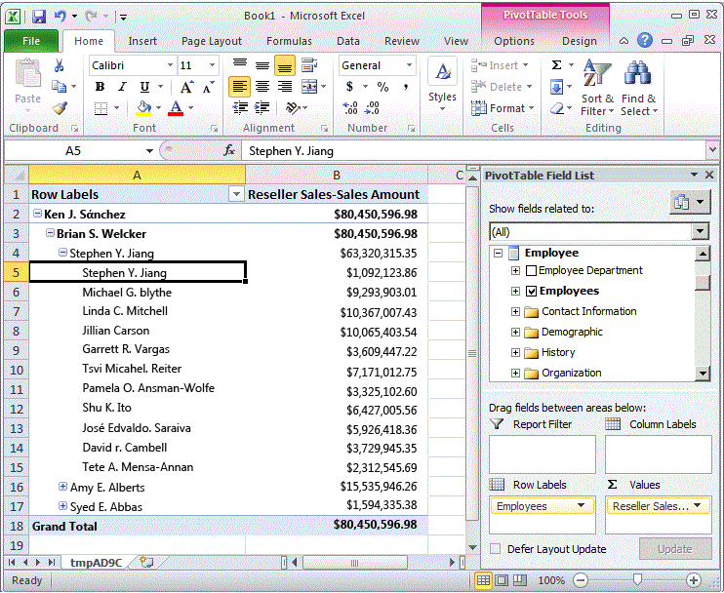
Notice that the sales made by each manager in Level 03 are also displayed in Level 04. This is because each manager is also an employee of another manager. In the next task, you will hide these sale amounts.

Modifying Parent Attribute Properties in the Employee Dimension
- Switch to Dimension Designer for the Employee dimension.
- Click the Dimension Structure tab, and then select the Employees attribute hierarchy in the Attributes pane.
Notice the unique icon for this attribute. This icon signifies that the attribute is the parent key in a parent-child hierarchy. Notice also, in the Properties window, that the Usage property for the attribute is defined as Parent. This property was set by the Dimension Wizard when the dimension was designed. The wizard automatically detected the parent-child relationship.
- In the Properties window, click the ellipsis button (...) in the NamingTemplate property cell.
In the Level Naming Template dialog box, you define the level naming template that determines the level names in the parent-child hierarchy that are displayed to users as they browse cubes.
- In the second row, the * row, type Employee Level * in the Name column, and then click the third row.
Notice under Result that each level will now be named "Employee Level" followed by a sequentially increasing number.
The following image shows the changes in the Level Naming Template dialog box.
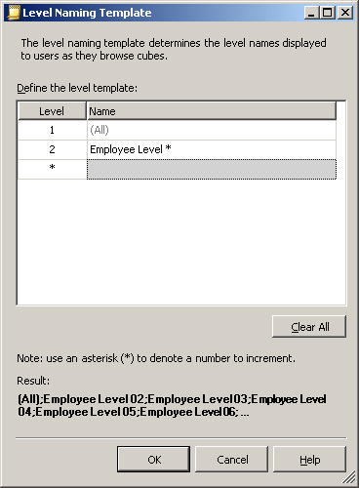
- Click OK.
- In the Properties window for the Employees attribute, in the MembersWithData property cell, select NonLeafDataHidden to change this value for the Employees attribute.
This will cause data that is related to non-leaf level members in the parent-child hierarchy to be hidden.

Browsing the Employee Dimension with the Modified Attributes
- On the Build menu of SQL Server Data Tools, click Deploy Analysis Services Tutorial.
- When deployment has successfully completed, switch to Cube Designer for the Analysis Services Tutorial cube, and then click Reconnect on the toolbar of the Browser tab.
- Click the Excel icon, and then click Enable.
- Drag Reseller Sales-Sales Amount to the Values area.
- Drag the Employees hierarchy to the Row Labels area.
The following image shows the changes that you made to the Employees hierarchy. Notice that Stephen Y. Jiang no longer appears as an employee of himself.
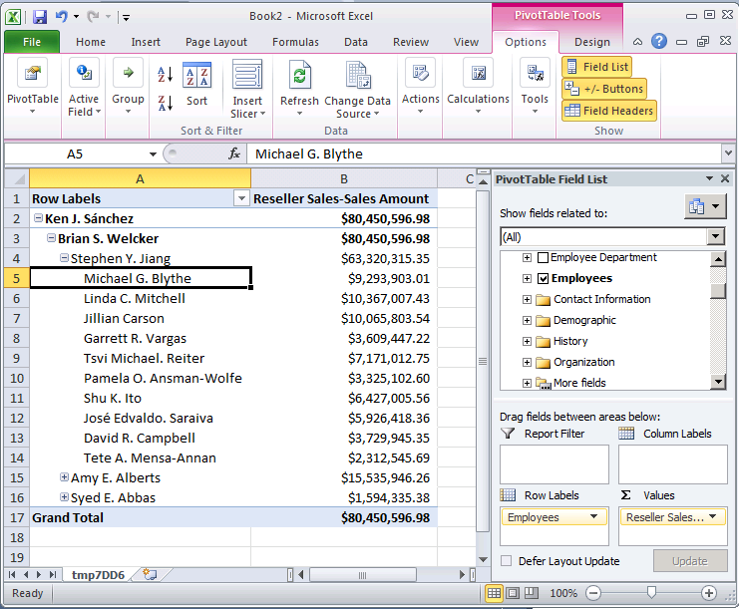
When you browse a cube, you typically dimension the members of one attribute hierarchy by the members of another attribute hierarchy. For example, you might group customer sales by city, by product purchased, or by gender. However, with certain types of attributes, it is useful to have Microsoft Analysis Services automatically create groupings of attribute members based on the distribution of the members within an attribute hierarchy. For example, you can have Analysis Services create groups of yearly income values for customers. When you do this, users who browse the attribute hierarchy will see the names and values of the groups instead of the members themselves. This limits the number of levels that are presented to users, which can be more useful for analysis.
The DiscretizationMethod property determines whether Analysis Services creates groupings, and determines the type of grouping that is performed. By default, Analysis Services does not perform any groupings. When you enable automatic groupings, you can allow Analysis Services to automatically determine the best grouping method based on the structure of the attribute, or you can choose one of the grouping algorithms in the following list to specify the grouping method:
EqualAreas
Analysis Services creates group ranges so that the total population of dimension members is distributed equally across the groups.
Clusters
Analysis Services creates groups by performing single-dimensional clustering on the input values by using the K-Means clustering method with Gaussian distributions. This option is valid only for numeric columns.
After you specify a grouping method, you must specify the number of groups, by using the DiscretizationBucketCount property. For more information, see Group Attribute Members (Discretization)
In the tasks in this topic, you will enable different types of groupings for the following: the yearly income values in the Customer dimension; the number of employee sick leave hours in the Employees dimension; and the number of employee vacation hours in the Employees dimension. You will then process and browse the Analysis Services Tutorial cube to view the effect of the member groups. Finally, you will modify the member group properties to see the effect of the change in grouping type.

Grouping Attribute Hierarchy Members in the Customer Dimension
- In Solution Explorer, double-click Customer in the Dimensions folder to open Dimension Designer for the Customer dimension.
- In the Data Source View pane, right-click the Customer table, and then click Explore Data.
Notice the range of values for the YearlyIncome column. These values become the members of the Yearly Income attribute hierarchy, unless you enable member grouping.
- Close the Explore Customer Table tab.
- In the Attributes pane, select Yearly Income.
- In the Properties window, change the value for the DiscretizationMethod property to Automatic and change the value for the DiscretizationBucketCount property to 5.
The following image shows the modified properties for Yearly Income.
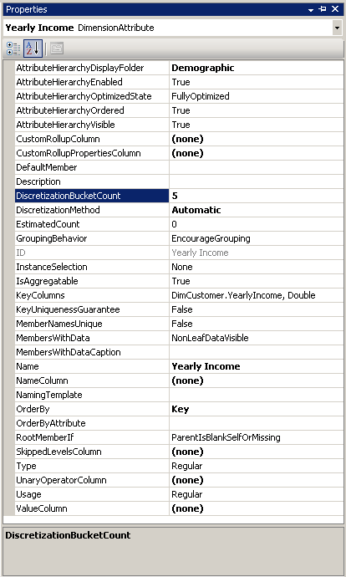

Grouping Attribute Hierarchy Members in the Employee Dimension
- Switch to Dimension Designer for the Employee dimension.
- In the Data Source View pane, right-click the Employee table, and then click Explore Data.
Notice the values for the SickLeaveHours column and the VacationHours column.
- Close the Explore Employee Table tab.
- In the Attributes pane, select Sick Leave Hours.
- In the Properties window, change the value for the DiscretizationMethod property to Clusters and change the value for the DiscretizationBucketCount property to 5.
- In the Attributes pane, select Vacation Hours.
- In the Properties window, change the value for the DiscretizationMethod property to Equal Areas and change the value for the DiscretizationBucketCount property to 5.

Browsing the Modified Attribute Hierarchies
- On the Build menu of SQL Server Data Tools, click Deploy Analysis Services Tutorial.
- When deployment has successfully completed, switch to Cube Designer for the Analysis Services Tutorial cube, and then click Reconnect on the Browser tab.
- Click the Excel icon, and then click Enable.
- Drag the Internet Sales-Sales Amount measure to the Values area of the PivotTable Field List.
- In the field list, expand the Product dimension, and then drag the Product Model Lines user hierarchy to the Row Labels area of the field list.
- Expand the Customer dimension in the field list, expand the Demographic display folder, and then drag the Yearly Income attribute hierarchy to the Column Labels area.
The members of the Yearly Income attribute hierarchy are now grouped into six buckets, including a bucket for sales to customers whose yearly income is unknown. Not all buckets are displayed.
- Remove the Yearly Income attribute hierarchy from the columns area and remove the Internet Sales-Sales Amount measure from the Values area.
- Add the Reseller Sales-Sales Amount measure to the data area.
- In the field list, expand the Employee dimension, expand Organization, then drag Sick Leave Hours to Column Labels.
Notice that all sales are made by employees within one of two groups. Notice also that the employees with 32 - 42 sick leave hours made significantly more sales than employees with 20 - 31 sick leave hours.
The following image shows sales dimensioned by employee sick leave hours.
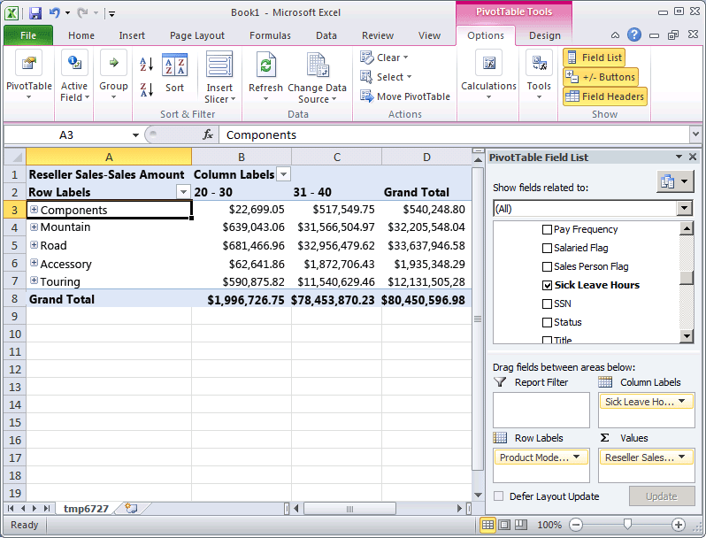
- Remove the Sick Leave Hours attribute hierarchy from the column area of the Data pane.
- Add Vacation Hours to the column area of the Data pane.
Notice that two groups appear, based on the equal areas grouping method. Three other groups are hidden because they contain no data values.

Modifying Grouping Properties and Reviewing the Effect of the Changes
- Switch to Dimension Designer for the Employee dimension, and then select Vacation Hours in the Attributes pane.
- In the Properties window, change the value of the DiscretizationBucketCount property to 10.
- On the Build menu of SQL Server Data Tools, click Deploy Analysis Services Tutorial.
- When deployment has successfully completed, switch back to Cube Designer for the Analysis Services Tutorial cube.
- Click Reconnect on the Browser tab, click the Excel icon, and then reconstruct the PivotTable so that you can view the effect of the change to the grouping method:
  - Drag Reseller Sales-Sales Amount to Values
  - Drag Vacation Hours (in the Employees Organization folder) to Columns
  - Drag Product Model Lines to Rows
Notice that there are now three groups of members of the Vacation Hours attribute that have sales values for products. (The other seven groups contain members with no sales data.)
By default, an attribute hierarchy is created for every attribute in a dimension, and each hierarchy is available for dimensioning fact data. This hierarchy consists of an "All" level and a detail level containing all members of the hierarchy. As you have already learned, you can organize attributes into user-defined hierarchies to provide navigation paths in a cube. Under certain circumstances, you may want to disable or hide some attributes and their hierarchies. For example, certain attributes such as social security numbers or national identification numbers, pay rates, birth dates, and login information are not attributes by which users will dimension cube information. Instead, this information is generally only viewed as details of a particular attribute member. You may want to hide these attribute hierarchies, leaving the attributes visible only as member properties of a specific attribute. You may also want to make members of other attributes, such as customer names or postal codes, visible only when they are viewed through a user hierarchy instead of independently through an attribute hierarchy. One reason to do so may be the sheer number of distinct members in the attribute hierarchy. Finally, to improve processing performance, you should disable attribute hierarchies that users will not use for browsing.
The value of the AttributeHierarchyEnabled property determines whether an attribute hierarchy is created. If this property is set to False, the attribute hierarchy is not created and the attribute cannot be used as a level in a user hierarchy; the attribute hierarchy exists as a member property only. However, a disabled attribute hierarchy can still be used to order the members of another attribute. If the value of the AttributeHierarchyEnabled property is set to True, the value of the AttributeHierarchyVisible property determines whether the attribute hierarchy is visible independent of its use in a user-defined hierarchy.
When an attribute hierarchy is enabled, you may want to specify values for the following three additional properties:
- IsAggregatable
By default, an (All) level is defined for all attribute hierarchies. To disable the (All) level for an enabled attribute hierarchy, set the value for this property to False.
Note
An attribute that has its IsAggregatable property set to false can only be used as the root of a user-defined hierarchy and must have a default member specified (otherwise, one will be chosen for you by the Analysis Services engine).
- AttributeHierarchyOrdered
By default, Analysis Services orders the members of enabled attribute hierarchies during processing, and then stores the members by the value of the OrderBy property, such as by Name or Key. If you do not care about ordering, you can increase processing performance by setting the value of this property to False.
- AttributeHierarchyOptimizedState
By default, Analysis Services creates an index for each enabled attribute hierarchy during processing, to improve query performance. If you do not plan to use an attribute hierarchy for browsing, you can increase processing performance by setting the value of this property to NotOptimized. However, if you use a hidden hierarchy as the key attribute for the dimension, creating an index of the attribute members will still improve performance.
These properties do not apply if an attribute hierarchy is disabled.
In the tasks in this topic, you will disable social security numbers and other attributes in the Employee dimension that will not be used for browsing. You will then hide the customer name and postal code attribute hierarchies in the Customer dimension. The large number of attribute members in these hierarchies will make browsing these hierarchies very slow independent of a user hierarchy.

Setting Attribute Hierarchy Properties in the Employee Dimension
- Switch to Dimension Designer for the Employee dimension, and then click the Browser tab.
- Verify that the following attribute hierarchies appear in the Hierarchy list:
  - Base Rate
  - Birth Date
  - Login ID
  - Manager SSN
  - SSN
- Switch to the Dimension Structure tab, and then select the following attributes in the Attributes pane. You can select multiple measures by clicking each while holding down the CTRL key:
  - Base Rate
  - Birth Date
  - Login ID
  - Manager SSN
  - SSN
- In the Properties window, set the value of the AttributeHierarchyEnabled property to False for the selected attributes.
Notice in the Attributes pane that the icon for each attribute has changed to indicate that the attribute is not enabled.
The following image shows the AttributeHierarchyEnabled property set to False for the selected attributes.
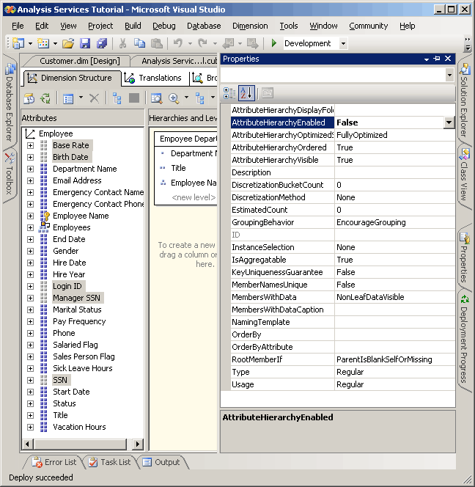
- On the Build menu, click Deploy Analysis Services Tutorial.
- When processing has successfully completed, switch to the Browser tab, click Reconnect, and then try to browse the modified attribute hierarchies.
Notice that the members of the modified attributes are not available for browsing as attribute hierarchies in the Hierarchy list. If you try to add one of the disabled attribute hierarchies as a level in a user hierarchy, you will receive an error notifying you that the attribute hierarchy must be enabled to participate in a user-defined hierarchy.

Setting Attribute Hierarchy Properties in the Customer Dimension
- Switch to Dimension Designer for the Customer dimension, and then click the Browser tab.
- Verify that the following attribute hierarchies appear in the Hierarchy list:
  - Full Name
  - Postal Code
- Switch to the Dimension Structure tab, and then select the following attributes in the Attributes pane by using the CTRL key to select multiple attributes at the same time:
  - Full Name
  - Postal Code
- In the Properties window, set the value of the AttributeHierarchyVisible property to False for the selected attributes.
Because the members of these attribute hierarchies will be used for dimensioning fact data, ordering and optimizing the members of these attribute hierarchies will improve performance. Therefore, the properties of these attributes should not be changed.
The following image shows the AttributeHierarchyVisible property set to False.
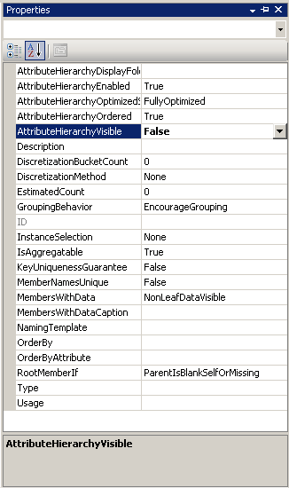
- Drag the Postal Code attribute from the Attributes pane into the Customer Geography user hierarchy in the Hierarchies and Levels pane, immediately under the City level.
Notice that a hidden attribute can still become a level in a user hierarchy.
- On the Build menu, click Deploy Analysis Services Tutorial.
- When deployment has successfully completed, switch to the Browser tab for the Customer dimension, and then click Reconnect.
- Try to select either of the modified attribute hierarchies from the Hierarchy list.
Notice that neither of the modified attribute hierarchies appears in the Hierarchy list.
- In the Hierarchy list, select Customer Geography, and then browse each level in the browser pane.
Notice that the hidden levels, Postal Code and Full Name, are visible in the user-defined hierarchy.
In Lesson 3, you learned how to sort attribute members based on either their name or key value. You also learned how to use a composite member key to affect attribute members and sort order. For more information, see Modifying the Date Dimension. However, if neither the name nor the key of the attribute provide the sort order that you want, you can use a secondary attribute to achieve the desired sort order. By defining a relationship between the attributes, you can use the second attribute to sort the members of the first attribute.
Attribute relationships define the relationships or dependencies between attributes. In a dimension that is based on a single relational table, all attributes are typically related to each other through the key attribute. This is because all the attributes for a dimension provide information about the members linked by the key attribute of the dimension to the facts in the fact table for each related measure group. In a dimension that is based on multiple tables, attributes are typically linked based on the join key between the tables. If the underlying data supports it, related attributes can be used to specify a sort order. For example, you might create a new attribute that provides the sort logic for a related attribute.
Dimension Designer lets you define additional relationships between attributes or change the default relationships to increase performance. The main constraint when you create an attribute relationship is to make sure that the attribute referred to has no more than one value for any member in the attribute to which it is related. When you define a relationship between two attributes, you can define the relationship as rigid or flexible, based on whether the relationships between members will change over time. For example, an employee might move to a different sales region, but a city will not move to a different state. If a relationship is defined as rigid, attribute aggregations are not recalculated every time the dimension is incrementally processed. However, if the relationship between members does change, the dimension must be fully processed. For more information, see Attribute Relationships, Define Attribute Relationships, Configure Attribute Relationship Properties, and Specifying Attribute Relationships Between Attributes in a User-Defined Hierarchy.
In the tasks in this topic, you will define a new attribute in the Date dimension based on an existing column in the underlying dimension table. You will use this new attribute to sort calendar month members chronologically instead of alphabetically. You will also define a new attribute in the Customer dimension based on the named calculation that you will use to sort the Commute Distance attribute members. In the tasks in the next topic, you will learn to use attribute relationships to increase query performance.

Defining an Attribute Relationship and Sort Order in the Date Dimension
- Open Dimension Designer for the Date dimension, and then review the OrderBy property for the Month Name attribute in the Properties window.
Notice that the Month Name attribute members are ordered by their key values.
- Switch to the Browser tab, verify that Calendar Date is selected in the Hierarchy list, and then expand the levels in the user-defined hierarchy to review the sort order for the calendar months.
Notice that the members of the attribute hierarchy are sorted based on the ASCII values of their member keys, which are month and year. In this case, sorting by the attribute name or key does not sort calendar months chronologically. To solve this, you will sort the members of the attribute hierarchy based on a new attribute, the MonthNumberOfYear attribute. You will create this attribute based on a column that conveniently exists in the Date dimension table.
- Switch to the Dimension Structure tab for the Date dimension, right-click MonthNumberOfYear in the Data Source View pane, and then click New Attribute from Column.
- In the Attributes pane, select Month Number Of Year, and then set the AttributeHierarchyEnabled property to False in the Properties window, set the AttributeHierarchyOptimizedState property to NotOptimized, and set the AttributeHierarchyOrdered property to False.
These settings will hide the attribute from users and will improve processing time. This attribute will not be used for browsing. It will only be used for ordering the members of another attribute.
Note
Sorting properties in the Properties window alphabetically will simplify this task as these three properties will be sorted adjacent to each other.
- Click the Attribute Relationships tab.
Notice that all the attributes in the Date dimension are related directly to the Date attribute, which is the member key that relates the dimension members to the facts in the related measure groups. There is no relationship defined between the Month Name attribute and the Month Number Of Year attribute.
- In the diagram, right-click the Month Name attribute and then select New Attribute Relationship.
- In the Create Attribute Relationship dialog box, the Source Attribute is Month Name. Set the Related Attribute to Month Number Of Year.
- In the Relationship type list, set the relationship type to Rigid.
The relationships between the members of the Month Name attribute and the Month Number Of Year attribute will not change over time. As a result, Analysis Services will not drop aggregations for this relationship during incremental processing. If a change does occur, a processing error will occur during incremental processing and you will need to perform a full process of the dimension. You are now ready to set the sort order for the members of Month Name.
- Click OK.
- Click the Dimension Structure tab.
- Select Month Name in the Attributes pane, and then change the value of the OrderBy property in the Properties window to AttributeKey and change the value of the OrderByAttribute property to Month Number Of Year.
- On the Build menu, click Deploy Analysis Services Tutorial.
- When deployment has successfully completed, switch to the Browser tab for the Date dimension, click Reconnect, and then browse the Calendar Date and Fiscal Date user hierarchies to verify that months now sort in chronological order.
Notice that the months are now sorted in chronological order, as shown in the following image.
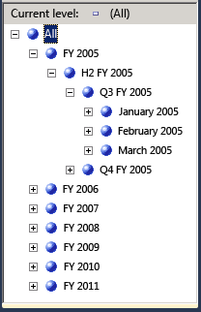

Defining Attribute Relationships and Sort Order in the Customer Dimension
- Switch to the Browser tab in Dimension Designer for the Customer dimension, and then browse the members of the Commute Distance attribute hierarchy.
Notice that the members of this attribute hierarchy are sorted based on the ASCII values of the member key. In this case, sorting by the attribute name or key does not sort the commute distances from least to most. In this task, you sort the members of the attribute hierarchy based on the CommuteDistanceSort named calculation that ascribes the appropriate sort number to each distinct value in the column. To save time, this named calculation has already been added to the Customer table in the Adventure Works DW data source view. You can switch to this data source view to view the SQL script that is used in this named calculation. For more information, see Define Named Calculations in a Data Source View (Analysis Services).
The following image shows the members of the Commute Distance attribute hierarchy, sorted by the ASCII values of the member key.
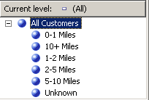
- Switch to the Dimension Structure tab in Dimension Designer for the Customer dimension, right-click CommuteDistanceSort in the Customer table in the Data Source View pane, and then click New Attribute from Column.
- In the Attributes pane, select Commute Distance Sort, and then set the AttributeHierarchyEnabled property for this attribute to False in the Properties window, set the AttributeHierarchyOptimizedState property to NotOptimized, and set the AttributeHierarchyOrdered property to False.
These settings will hide the attribute from users and will improve processing time. This attribute will not be used for browsing. It will only be used for ordering the members of another attribute.
- Select Geography, and then set its AttributeHierarchyVisible property to False in the Properties window, set its AttributeHierarchyOptimizedState property to NotOptimized, and set its AttributeHierarchyOrdered property to False.
These settings will hide the attribute from users and will improve processing time. This attribute will not be used for browsing. It will be only be used for ordering the members of another attribute. Because Geography has member properties, its AttributeHierarchyEnabled property must be set to True. Therefore, to hide the attribute, you set the AttributeHierarchyVisible property to False.
- Click the Attribute Relationships tab.
- In the attributes list, right-click the Commute Distance attribute and then select New Attribute Relationship.
- In the Create Attribute Relationship dialog box, the Source Attribute is Commute Distance. Set the Related Attribute to Commute Distance Sort.
- In the Relationship type list, set the relationship type to Rigid.
The relationship between the members of the Commute Distance attribute and the Commute Distance Sort attribute will not change over time.
- Click OK.
You are now ready to set the sort order for the Commute Distance attribute.
- Click the Dimension Structure tab.
- In the Attributes pane, select Commute Distance, and then change the value of the OrderBy property in the Properties window to AttributeKey, and change the value of the OrderByAttribute property to Commute Distance Sort.
- On the Build menu, click Deploy Analysis Services Tutorial.
- When deployment has successfully completed, switch to the Browser tab of Dimension Designer for the Customer dimension, click Reconnect, and then browse the Commute Distance attribute hierarchy.
Notice that the attribute hierarchy members are now sorted in a logical order based on increasing distance, as shown in the following image.
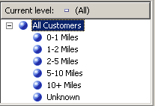
As you have already learned in this tutorial, you can organize attribute hierarchies into levels within user hierarchies to provide navigation paths for users in a cube. A user hierarchy can represent a natural hierarchy, such as city, state, and country, or can just represent a navigation path, such as employee name, title, and department name. To the user navigating a hierarchy, these two types of user hierarchies are the same.
With a natural hierarchy, if you define attribute relationships between the attributes that make up the levels, Analysis Services can use an aggregation from one attribute to obtain the results from a related attribute. If there are no defined relationships between attributes, Analysis Services will aggregate all non-key attributes from the key attribute. Therefore, if the underlying data supports it, you should define attribute relationships between attributes. Defining attribute relationships improves dimension, partition, and query processing performance. For more information, see Define Attribute Relationships and Attribute Relationships.
When you define attribute relationships, you can specify that the relationship is either flexible or rigid. If you define a relationship as rigid, Analysis Services retains aggregations when the dimension is updated. If a relationship that is defined as rigid actually changes, Analysis Services generates an error during processing unless the dimension is fully processed. Specifying the appropriate relationships and relationship properties increases query and processing performance. For more information, see Define Attribute Relationships, and User Hierarchy Properties.
In the tasks in this topic, you define attribute relationships for the attributes in the natural user hierarchies in the Analysis Services Tutorial project. These include the Customer Geography hierarchy in the Customer dimension, the Sales Territory hierarchy in the Sales Territory dimension, the Product Model Lines hierarchy in the Product dimension, and the Fiscal Date and Calendar Date hierarchies in the Date dimension. These user hierarchies are all natural hierarchies.

Defining Attribute Relationships for Attributes in the Customer Geography Hierarchy
- Switch to Dimension Designer for the Customer dimension, and then click the Dimension Structure tab.
In the Hierarchies pane, notice the levels in the Customer Geography user-defined hierarchy. This hierarchy is currently just a drill-down path for users, as no relationship between levels or attributes have been defined.
- Click the Attribute Relationships tab.
Notice the four attribute relationships that link the non-key attributes from the Geography table to the key attribute from the Geography table. The Geography attribute is related to the Full Name attribute. The Postal Code attribute is indirectly linked to the Full Name attribute through the Geography attribute, because the Postal Code is linked to the Geography attribute and the Geography attribute is linked to the Full Name attribute. Next, we will change the attribute relationships so that they do not use the Geography attribute.
- In the diagram, right-click the Full Name attribute and then select New Attribute Relationship.
- In the Create Attribute Relationship dialog box, the Source Attribute is Full Name. Set the Related Attribute to Postal Code. In the Relationship type list, leave the relationship type set to Flexible because relationships between the members might change over time.
- Click OK.
A warning icon appears in the diagram because the relationship is redundant. The relationship Full Name -> Geography-> Postal Code already existed, and you just created the relationship Full Name -> Postal Code. The relationship Geography-> Postal Code is now redundant, so we will remove it.
- In the Attribute Relationships pane, right-click Geography-> Postal Code and then click Delete.
- When the Delete Objects dialog box appears, click OK.
- In the diagram, right-click the Postal Code attribute and then select New Attribute Relationship.
- In the Create Attribute Relationship dialog box, the Source Attribute is Postal Code. Set the Related Attribute to City. In the Relationship type list, leave the relationship type set to Flexible.
- Click OK.
The relationship Geography-> City is now redundant so we will delete it.
- In the Attribute Relationships pane, right-click Geography-> City and then click Delete.
- When the Delete Objects dialog box appears, click OK.
- In the diagram, right-click the City attribute and then select New Attribute Relationship.
- In the Create Attribute Relationship dialog box, the Source Attribute is City. Set the Related Attribute to State-Province. In the Relationship type list, set the relationship type to Rigid because the relationship between a city and a state will not change over time.
- Click OK.
- Right-click the arrow between Geography and State-Province and then click Delete.
- When the Delete Objects dialog box appears, click OK.
- In the diagram, right-click the State-Province attribute and then select New Attribute Relationship.
- In the Create Attribute Relationship dialog box, the Source Attribute is State-Province. Set the Related Attribute to Country-Region. In the Relationship type list, set the relationship type to Rigid because the relationship between a state-province and a country-region will not change over time.
- Click OK.
- In the Attribute Relationships pane, right-click Geography-> Country-Region and then click Delete.
- When the Delete Objects dialog box appears, click OK.
- Click the Dimension Structure tab.
Notice that when you delete the last attribute relationship between Geography and other attributes, that Geography itself is deleted. This is because the attribute is no longer used.
- On the File menu, click Save All.

Defining Attribute Relationships for Attributes in the Sales Territory Hierarchy
- Open Dimension Designer for the Sales Territory dimension, and then click the Attribute Relationships tab.
- In the diagram, right-click the Sales Territory Country attribute and then select New Attribute Relationship.
- In the Create Attribute Relationship dialog box, the Source Attribute is Sales Territory Country. Set the Related Attribute to Sales Territory Group. In the Relationship type list, leave the relationship type set to Flexible.
- Click OK.
Sales Territory Group is now linked to Sales Territory Country, and Sales Territory Country is now linked to Sales Territory Region. The RelationshipType property for each of these relationships is set to Flexible because the groupings of regions within a country might change over time and because the groupings of countries into groups might change over time.

Defining Attribute Relationships for Attributes in the Product Model Lines Hierarchy
- Open Dimension Designer for the Product dimension, and then click the Attribute Relationships tab.
- In the diagram, right-click the Model Name attribute and then select New Attribute Relationship.
- In the Create Attribute Relationship dialog box, the Source Attribute is Model Name. Set the Related Attribute to Product Line. In the Relationship type list, leave the relationship type set to Flexible.
- Click OK.

Defining Attribute Relationships for Attributes in the Fiscal Date Hierarchy
- Switch to Dimension Designer for the Date dimension, and then click the Attribute Relationships tab.
- In the diagram, right-click the Month Name attribute and then select New Attribute Relationship.
- In the Create Attribute Relationship dialog box, the Source Attribute is Month Name. Set the Related Attribute to Fiscal Quarter. In the Relationship type list, set the relationship type to Rigid.
- Click OK.
- In the diagram, right-click the Fiscal Quarter attribute and then select New Attribute Relationship.
- In the Create Attribute Relationship dialog box, the Source Attribute is Fiscal Quarter. Set the Related Attribute to Fiscal Semester. In the Relationship type list, set the relationship type to Rigid.
- Click OK.
- In the diagram, right-click the Fiscal Semester attribute and then select New Attribute Relationship.
- In the Create Attribute Relationship dialog box, the Source Attribute is Fiscal Semester. Set the Related Attribute to Fiscal Year. In the Relationship type list, set the relationship type to Rigid.
- Click OK.

Defining Attribute Relationships for Attributes in the Calendar Date Hierarchy
- In the diagram, right-click the Month Name attribute and then select New Attribute Relationship.
- In the Create Attribute Relationship dialog box, the Source Attribute is Month Name. Set the Related Attribute to Calendar Quarter. In the Relationship type list, set the relationship type to Rigid.
- Click OK.
- In the diagram, right-click the Calendar Quarter attribute and then select New Attribute Relationship.
- In the Create Attribute Relationship dialog box, the Source Attribute is Calendar Quarter. Set the Related Attribute to Calendar Semester. In the Relationship type list, set the relationship type to Rigid.
- Click OK.
- In the diagram, right-click the Calendar Semester attribute and then select New Attribute Relationship.
- In the Create Attribute Relationship dialog box, the Source Attribute is Calendar Semester. Set the Related Attribute to Calendar Year. In the Relationship type list, set the relationship type to Rigid.
- Click OK.

Defining Attribute Relationships for Attributes in the Geography Hierarchy
- Open Dimension Designer for the Geography dimension, and then click the Attribute Relationships tab.
- In the diagram, right-click the Postal Code attribute and then select New Attribute Relationship.
- In the Create Attribute Relationship dialog box, the Source Attribute is Postal Code. Set the Related Attribute to City. In the Relationship type list, set the relationship type to Flexible.
- Click OK.
- In the diagram, right-click the City attribute and then select New Attribute Relationship.
- In the Create Attribute Relationship dialog box, the Source Attribute is City. Set the Related Attribute to State-Province. In the Relationship type list, set the relationship type to Rigid.
- Click OK.
- In the diagram, right-click the State-Province attribute and then select New Attribute Relationship.
- In the Create Attribute Relationship dialog box, the Source Attribute is State-Province. Set the Related Attribute to Country-Region. In the Relationship type list, set the relationship type to Rigid.
- Click OK.
- In the diagram, right-click the Geography Key attribute and then select Properties.
- Set the AttributeHierarchyOptimizedState property to NotOptimized, set the AttributeHierarchyOrdered property to False, and set the AttributeHierarchyVisible property to False.
- On the File menu, click Save All.
- On the Build menu of SQL Server Data Tools, click Deploy Analysis Services Tutorial.
When Analysis Services processes a dimension, all the distinct values from the underlying columns in the tables, or views in the data source view, populate the attributes in the dimension. If Analysis Services encounters a null value during processing, by default, it converts this null to a zero for numeric columns or to an empty string for string columns. You can modify the default settings or convert null values in your extract, transform, and load process (if any) of the underlying relational data warehouse. Additionally, you can have Analysis Services convert the null value to a designated value by configuring three properties: the UnknownMember and UnknownMemberName properties for the dimension, and the NullProcessing property for the dimension's key attribute.
The Dimension Wizard and the Cube Wizard will enable these properties for you based on whether the key attribute of a dimension is nullable or the root attribute of a snowflake dimension is based on a nullable column. In these cases, the NullProcessing property of the key attribute will be set to UnknownMember and the UnknownMember property will be set to Visible.
However, when you build snowflaked dimensions incrementally, as we are doing with the Product dimension in this tutorial, or when you define dimensions using Dimension Designer and then incorporate these existing dimensions into a cube, the UnknownMember and NullProcessing properties might need to be set manually.
In the tasks in this topic, you will add the product category and product subcategory attributes to the Product dimension from snowflaked tables that you will add to the Adventure Works DW data source view. You will then enable the UnknownMember property for the Product dimension, specify Assembly Components as the value for the UnknownMemberName property, relate the Subcategory and Category attributes to the product name attribute, and then define custom error handling for the member key attribute that links the snowflaked tables.
Note
If you have added the Subcategory and Category attributes when you originally defined the Analysis Services Tutorial cube using the Cube Wizard, these steps would have been performed for you automatically.

Reviewing Error Handling and Unknown Member Properties in the Product Dimension
- Switch to Dimension Designer for the Product dimension, click the Dimension Structure tab, and then select Product in the Attributes pane.
This enables you to view and modify the properties of the dimension itself.
- In the Properties window, review the UnknownMember and UnknownMemberName properties.
Notice that the UnknownMember property is not enabled, because its value is set to None instead of Visible or Hidden, and that no name is specified for the UnknownMemberName property.
- In the Properties window, select (custom) in the ErrorConfiguration property cell, and then expand the ErrorConfiguration properties collection.
Setting the ErrorConfiguration property to (custom) allows you to view the default error configuration settings - it does not change any settings.
- Review the key and null key error configuration properties, but do not make any changes.
Notice that, by default, when null keys are converted to the unknown member and the processing error associated with this conversion is ignored.
The following image shows the property settings for the ErrorConfiguration properties collection.
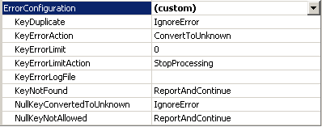
- Click the Browser tab, verify that Product Model Lines is selected in the Hierarchy list, and then expand All Products.
Notice the five members of the Product Line level.
- Expand Components, and then expand the unlabeled member of the Model Name level.
This level contains the assembly components that are used when building other components, starting with the Adjustable Race product, as shown in the following image.
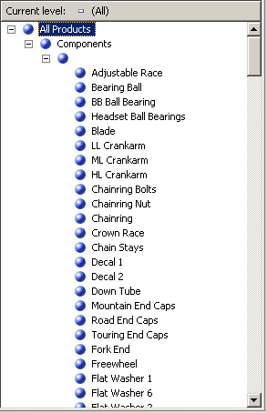

Defining Attributes from Snowflaked Tables and a Product Category User-Defined Hierarchy
- Open Data Source View Designer for the Adventure Works DW data source view, select Reseller Sales in the Diagram Organizer pane, and then click Add/Remove Objects on the Data Source View menu of SQL Server Data Tools.
The Add/Remove Tables dialog box opens.
- In the Included objects list, select DimProduct (dbo), and then click Add Related Tables.
Both DimProductSubcategory (dbo) and FactProductInventory (dbo) are added. Remove FactProductInventory (dbo) so that just the DimProductSubcategory (dbo) table is added to the Included objects list.
- With the DimProductSubcategory (dbo) table selected by default as the table most recently added, click Add Related Tables again.
The DimProductCategory (dbo) table is added to the Included objects list.
- Click OK.
- On the Format menu of SQL Server Data Tools, point to Auto Layout, and then click Diagram.
Notice that the DimProductSubcategory (dbo) table and DimProductCategory (dbo) table are linked to each other, and also to the ResellerSales table through the Product table.
- Switch to Dimension Designer for the Product dimension, and then click the Dimension Structure tab.
- Right-click anywhere in the Data Source View pane, and then click Show All Tables.
- In the Data Source View pane, locate the DimProductCategory table, right-click ProductCategoryKey in that table, and then click New Attribute from Column.
- In the Attributes pane, change the name of this new attribute to Category.
- In the Properties window, click in the NameColumn property field and then click the browse (...) button to open the Name Column dialog box.
- Select EnglishProductCategoryName in the Source column list and then click OK.
- In the Data Source View pane, locate the DimProductSubcategory table, right-click ProductSubcategoryKey in that table, and then click New Attribute from Column.
- In the Attributes pane, change the name of this new attribute to Subcategory.
- In the Properties window, click in the NameColumn property field and then click the browse (...) button to open the Name Column dialog box.
- Select EnglishProductSubcategoryName in the Source column list and then click OK.
- Create a new user-defined hierarchy called Product Categories with the following levels, in order from top to bottom: Category, Subcategory, and Product Name.
- Specify All Products as the value for the AllMemberName property of the Product Categories user-defined hierarchy.

Browsing the User-Defined Hierarchies in the Product Dimension
- On the toolbar of the Dimension Structure tab of Dimension Designer for the Product dimension, click Process.
- Click Yes to build and deploy the project, and then click Run to process the Product dimension.
- When processing has succeeded, expand Processing Dimension 'Product' completed successfully in the Process Progress dialog box, expand Processing Dimension Attribute 'Product Name' completed, and then expand SQL queries 1.
- Click the SELECT DISTINCT query and then click View Details.
Notice that a WHERE clause has been added to the SELECT DISTINCT clause that removes those products that have no value in the ProductSubcategoryKey column, as shown in the following image.
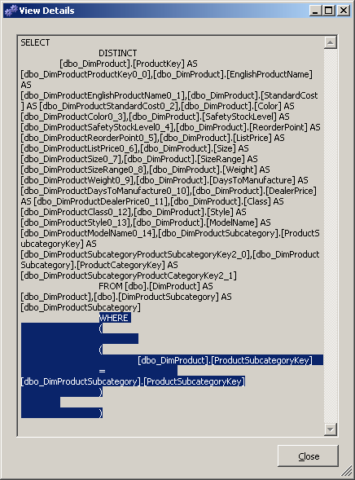
- Click Close three times to close all processing dialog boxes.
- Click the Browser tab in Dimension Designer for the Product dimension, and then click Reconnect.
- Verify that Product Model Lines appears in the Hierarchy list, expand All Products, and then expand Components.
- Select Product Categories in the Hierarchy list, expand All Products, and then expand Components.
Notice that none of the assembly components appear.
To modify the behavior mentioned in the previous task, you will enable the UnknownMember property of the Products dimension, set a value for the UnknownMemberName property, set the NullProcessing property for the Subcategory and Model Name attributes to UnknownMember, define the Category attribute as a related attribute of the Subcategory attribute, and then define the Product Line attribute as a related attribute of the Model Name attribute. These steps will cause Analysis Services to use the unknown member name value for each product that does not have a value for the SubcategoryKey column, as you will see in the following task.

Enabling the Unknown Member, Defining Attribute Relationships, and Specifying Custom Processing Properties for Nulls
- Click the Dimension Structure tab in Dimension Designer for the Product dimension, and then select Product in the Attributes pane.
- In the Properties window, change the UnknownMember property to Visible, and then change the value for the UnknownMemberName property to Assembly Components.
Changing the UnknownMember property to either Visible or Hidden enables the UnknownMember property for the dimension.
- Click the Attribute Relationships tab.
- In the diagram, right-click the Subcategory attribute and then select New Attribute Relationship.
- In the Create Attribute Relationship dialog box, the Source Attribute is Subcategory. Set the Related Attribute to Category. Leave the relationship type set to Flexible.
- Click OK.
- In the Attributes pane, select Subcategory.
- In the Properties window, expand the KeyColumns property and then expand the DimProductSubcategory.ProductSubcategoryKey (Integer) property.
- Change the NullProcessing property to UnknownMember.
- In the Attributes pane, select Model Name.
- In the Properties window, expand the KeyColumns property and then expand the Product.ModelName (WChar) property.
- Change the NullProcessing property to UnknownMember.
Because of these changes, when Analysis Services encounters a null value for the Subcategory attribute or the Model Name attribute during processing, the unknown member value will be substituted as the key value, and the user-defined hierarchies will be constructed correctly.

Browsing the Product Dimension Again
- On the Build menu, click Deploy Analysis Services Tutorial.
- When deployment has successfully completed, click the Browser tab in Dimension Designer for the Product dimension, and then click Reconnect.
- Verify that Product Categories is selected in the Hierarchy list, and then expand All Products.
Notice that Assembly Components appears as a new member of the Category level.
- Expand the Assembly Components member of the Category level and then expand the Assembly Components member of the Subcategory level.
Notice that all the assembly components now appear at the Product Name level, as shown in the following image.
